

Reep Reepham Church of England

Primary School

**Reading**

We love reading and believe every child can become a fluent reader! Reading opens doors and inspires imagination. Learning to read fluently means a child can access the full curriculum and will help them become independent learners. The fundamental tool for reading is Phonics. At Reepham School, we follow the Little Wandle Letters and Sounds phonics programme, with children in Reception through to Year 2 having daily phonics sessions to embed these skills. We also want children to have a love of reading which is why we have a daily story time in all classes where children can enjoy listening to and sharing books.

**Daily Phonics in Reception and Key Stage 1**

We teach phonics for around 30 minutes a day in Key Stage 1, building from shorter sessions at the beginning of Reception. We follow the [Little Wandle Letters and Sounds Revised expectations of progress](https://www.littlewandlelettersandsounds.org.uk/wp-content/uploads/2021/06/Programme-Overview_Reception-and-Year-1.pdf). More information will be available on our website including videos to help you at home.

To ensure all children keep pace with the scheme we have regular “keep-up” sessions for any child that needs it. In Year 2, Phonics sessions will become more spelling focused as the year goes on.

**Reading Lessons**

Complimenting Phonics sessions in Reception and Year 1 are twice weekly Reading Practice lessons. These:

* are taught by a fully trained adult to small groups of approximately six children;
* use books matched to the children’s secure phonic knowledge;
* are monitored by the class teacher, who rotates and works with each group on a regular basis.

Each Reading Practice session has a clear focus, so that the demands of the session do not overload the children’s working memory. The Reading Practice sessions have been designed to focus on three key reading skills:

* decoding;
* prosody: teaching children to read with understanding and expression;
* comprehension: teaching children to understand the text.

**Children will take the book used in these sessions home to read with their parents and celebrate their reading.**

As children move through Year 2, and continuing all the way until they finish in Year 6, they will have a minimum of 4 Reading Lessons a week. These will follow a whole class reading approach. Children in all year groups will also be read to regularly so they develop their love of reading.

**Home Readers**

In Reception and Year 1, **we are no longer using book band colours**, instead pupils will be sent home with a book that matches their individual Phonics level. The books sent home are to celebrate reading and you should find your child can read around 90% of the book fluently. This is a research-based approach to build their confidence and fluency. One of the books they bring home will be the same book they have used in their Reading Practice session at school. Remember it is not a race to try and get to harder books, re-reading the same book has been found to greatly improve fluency and reading skills. When children are working securely in Phase 6 (likely within Year 2), they will move off our matched Phonics books and start on a Turquoise banded book. They will stay on a book band until they are considered a fluent “free reader”. To find out more about which book set matches which phonics phase, please see our ‘Phonics and Early Reading’ policy, available on our website.

**Bookmarks**

This year, we have introduced bookmarks to keep record of individual children’s reading. In Reception and Key Stage 1, there is space available on the back of the bookmark to record any sounds or words that a child may need to practice.

We would really appreciate you completing the bookmark when they read at home. This will also help them enter our termly reading raffle, as every completed bookmark equates to an entry in the raffle in Reception and Key Stage 1 (see Mr Randall’s reading competition info below).

**Look out for our Reepham Recommended Reads:**

In all of our class libraries we have books with a sticker showing it is a Recommended Read - these books have been identified as being age relevant, having engaging stories or being a modern classic. It is not expected younger children in Reception & Key Stage 1 will be able to read these independently, instead they should be shared with an adult. If you read these books with your child, look inside the front or back cover to find some questions you can use to discuss the 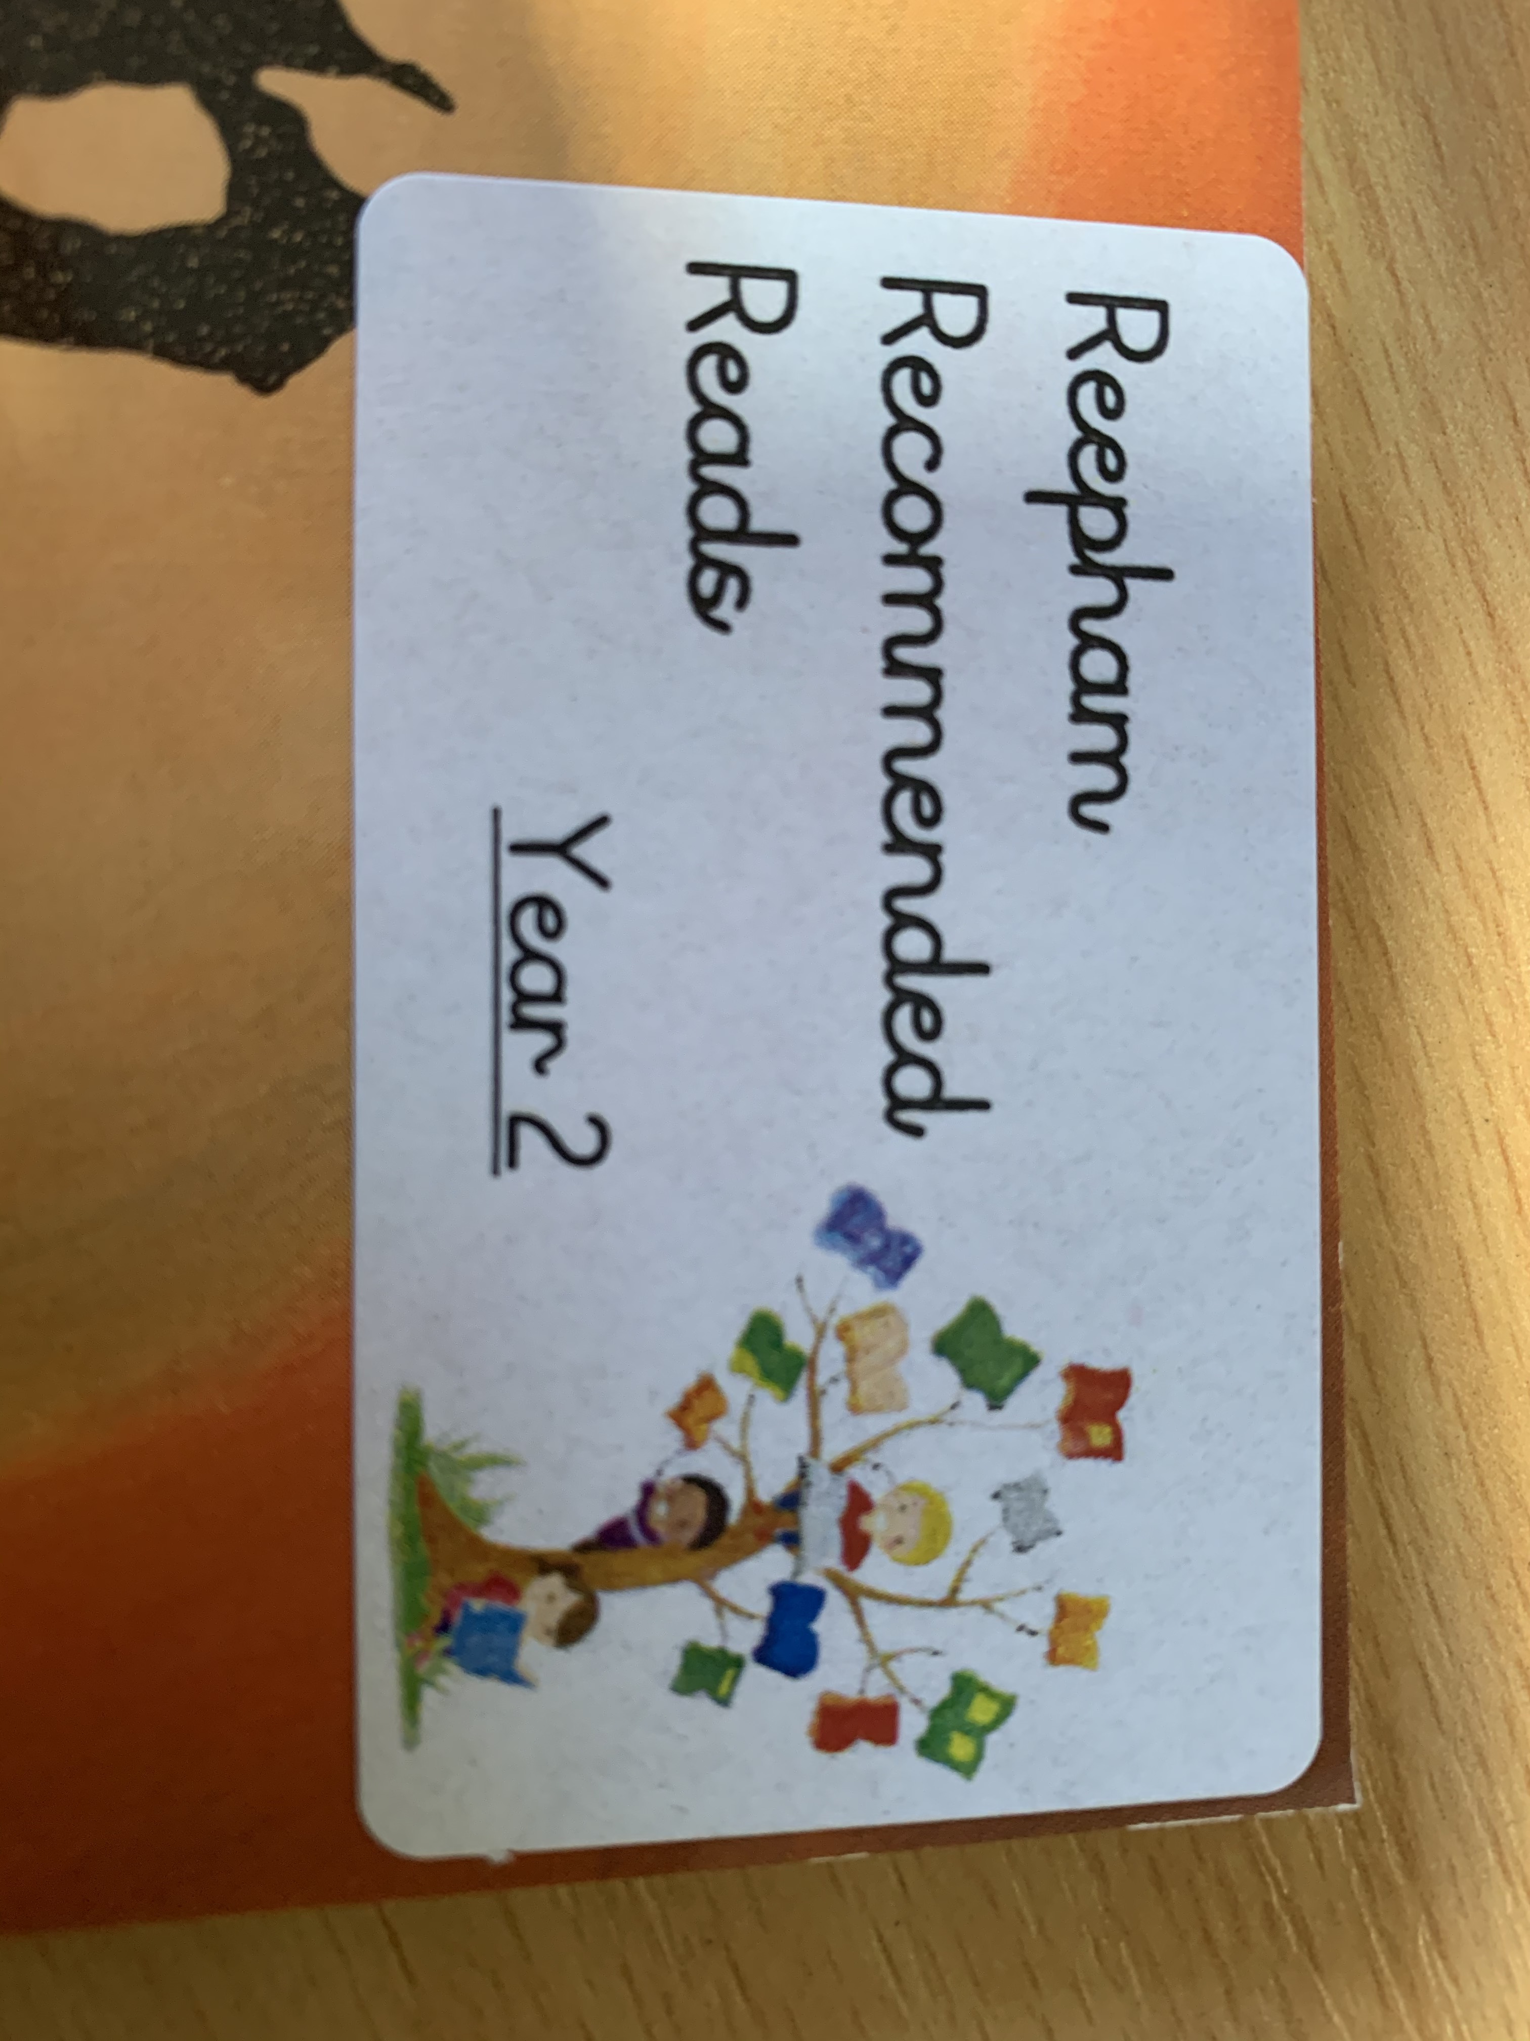book.

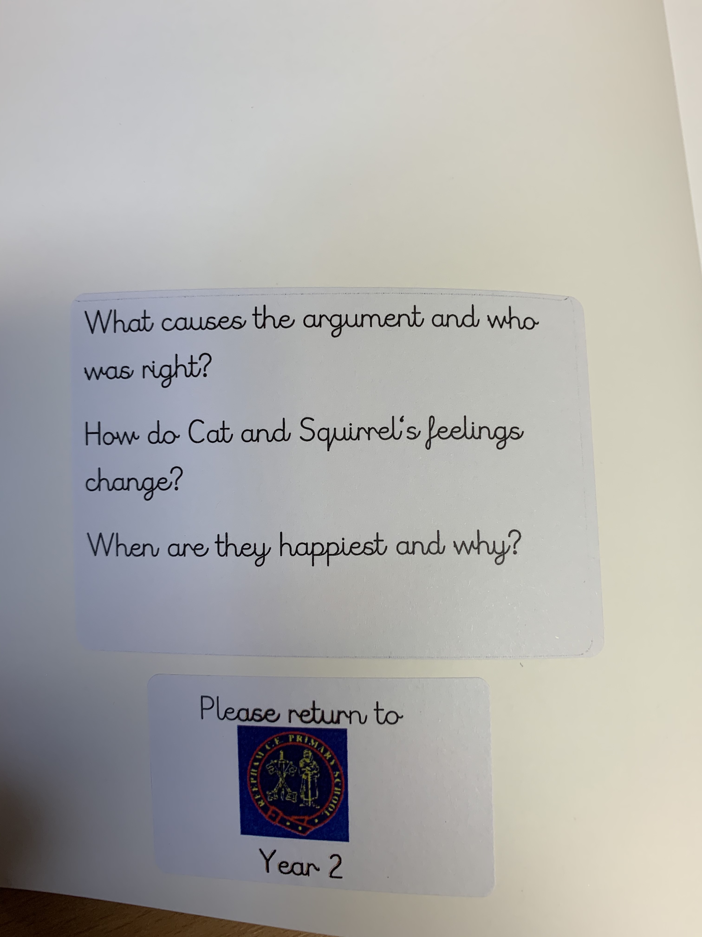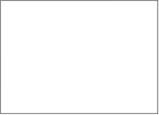

**Changing Books in Individual classes:**

**Reception:**

Children will start their reading journey using a picture book from our Phonics scheme, please use these to tell the story and develop their understanding of narrative. At the start of the year, children also bring home a letter fan for you to practice the sounds they have learnt in Phonics. Children will then progress onto books that match their Phonics level. These books should be read more than once to improve fluency. **The books will be changed by the teacher** twice a week.

Children will also be able to take a book from the **‘bedtime story’ box**. These are engaging books which are for adults to share with their children at home. These books will be changed once a week.

**Year 1:**

In Year 1, Children take home their Reading Practice book on a **Tuesday** and an additional book matched to their phonics on a **Friday** every week. Please remember it is not just about reading the book once - children should revisit the book to improve fluency, prosody (expression) and comprehension. Books may be repeated if we feel it would help support a child’s confidence.

On Fridays, children will be given a “Recommended Read” or another book from the class library. They may complete a simple book review as part of their homework. Please ensure all our books are returned so they can be enjoyed and spark the love of reading in others.

**Year 2:**

In Year 2, we hear children read at least once a week. As the **reading scheme books** get longer in Year 2, they will only be changed by the teacher as required. Again, please get children to reread shorter books to aid fluency and ensure you complete their reading bookmark. Whilst children are on the reading scheme, they may also take home a book from the class library. Again, look out for our **Reepham Recommended Reads.** It is not expected children will necessarily be able to read them independently, but they are fantastic for you to share with them and discuss the questions inside the front covers. Children may start to move beyond the reading scheme, if this is the case, we have a selection of more accessible, exciting novels for them to move onto, which will encourage confidence and independence.

**Key Stage 2:**

Following our Phonics reading scheme, your child will progress onto ‘free readers’; this decision is made by the class teacher. Each class/key stage has set up its library to meet the needs of the pupils in that specific class. This will ensure books are suitable and accessible for all the children. All children should have a home reading book from the class library or as they move further up the school, bring in books from home. If your child chooses to do this, we ask that you help ensure they have a suitable book, we do regularly listen to them read and if we don’t think it is suitable, we will ask them to change it. Each class also has a **Reepham Recommended Reads** section which children will be encouraged to use.

**Mr Randall’s Reading competition:** Starting in Year 1, we run a termly reading competition, where every time a child completes their book mark (Key Stage 1) or meets the expectations set by their class teacher (Key Stage 2), they will be entered into a raffle and have the chance of winning a book of their choice. This may include a trip to Waterstones, or ordering a book online. The more you read at home, the more chances you have of winning! Remember they don’t have to just read their school book, so put evidence of any other books or comics they read at home. We want all children to develop a love of reading!

Thank you for your continued support.