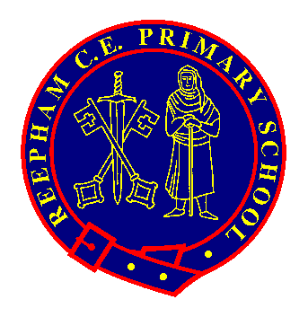
Pupils Name:

Year Group:

The ‘Reepham Rangers’ badge scheme has been created to offer opportunities to celebrate achievements outside of the National Curriculum. There are 5 badges to collect: Resilience Award, Social Action Award, Arts Award, Teamwork Award and Our World Award.

The KS2 Challenges are designed so that 2 or 3 will be able to be completed in school, but they will also require children to show commitment outside of school. This means that they will have 4 years to complete all of the challenges if they would like to achieve all the badges.

Please can you send in photos or a PPT to support the evidence for the challenges and this will allow us to check the criteria.

When your child has achieved 5 out of the 6 challenges, please return this form to their class teacher and the award will be presented in celebration worship.

BE KNOWN. BE LOVED. BELONG
Resilience Award | Examples  Please complete 5 out of the 6 challenges to achieve the award. | Evidence  (Please list the evidence below and take photos)
1) Show improvement in an area you find tricky. | Improve your times tables scores by practicing more at home. Try to get on our ‘personal best sports board’ by improving your skills. Improve your Lexia level.
2) Persevere to overcome an obstacle. | Create a plan that shows you taking responsibility to overcome an obstacle. Mind map a problem or set yourself small steps to succeed at something. Maybe this will relate to school work, a friendship problem, a sports activity or something you do outside of school.
3) Be resilient when something doesn’t go well. | Show self-reflection when something doesn’t turn out the way you expected or be resilient in defeat. You may show this by speaking to your teacher about your work, debriefing with a coach after a sporting event or considering why you and your friends have fallen out. You might present this in the form of a diary extract, advice poster or a poem about how you felt and what you will do.
4) Be inspired by someone who overcame a problem in history to make the world better. | Present information in your Class Worship about someone who changed something for the better. Maybe you have been inspired by a sporting hero or a rights activist? Maybe you are amazed at what the Roman Empire gave us and want to research this at home.
5) Debate something that matters to you. | Organise a discussion in your class or with your friends about something that you feel can be further improved. Maybe this relates to something in school or a world event, explain what has been done and why you think we shouldn’t give up yet.
6) Know your own identity. | Be clear about your values and what matters to you. Speak proudly about you and your friend’s life choices. Explain what you want to be when you grow up and what it is you need to do to achieve these goals.
School Values link: Responsibility, Respect and Hope. BE KNOWN. BE LOVED. BELONG

