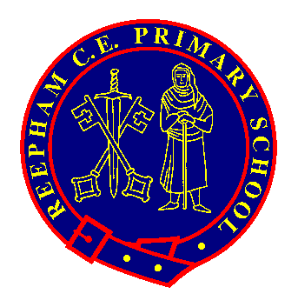
Pupils Name:

Year Group:

The ‘Reepham Rangers’ badge scheme has been created to offer opportunities to celebrate achievements outside of the National Curriculum. There are 5 badges to collect: Resilience Award, Social Action Award, Arts Award, Teamwork Award and Our World Award.

The KS2 Challenges are designed so that 2 or 3 will be able to be completed in school, but they will also require children to show commitment outside of school. This means that they will have 4 years to complete all of the challenges if they would like to achieve all the badges.

Please can you send in photos or a PPT to support the evidence for the challenges and this will allow us to check the criteria.

When your child has achieved 5 out of the 6 challenges, please return this form to their class teacher and the award will be presented in celebration worship.

BE KNOWN. BE LOVED. BELONG
Arts Award | Examples  Please complete 5 out of the 6 challenges to achieve the award. | Evidence  (Please list the evidence below and take photos)
1) Create something you are proud of and show it to your peers. | Paint a picture, do a sketch, build something or write a song that is of a high quality and you are proud of.
2) Show confidence when presenting to a group. | Speak clearly when presenting something you have created to a group. Discuss your inspiration, the process of what you did and what you would do differently-without being prompted.
3) Collaborate with a group to create art that has a purpose. | Beyond the classroom make a group piece about something that matters to you.
4) Perform in a show. | Perform in a play, sing with a choir or show a dance to a group of your peers at school.
5) Appreciate a range of artists and explain your preferences. | Visit an exhibition or a museum. Find a piece of art that inspires, explain why you like it and who made it. This might be art you have seen in a book or on the internet. It could be a painting, sculpture or piece of classical music.
6) Perform in a show outside of school. | Take part in an event that is performed on a stage or in-front of an audience, this could be a show, part of a dance troupe, acting in a play, singing in a choir, reading in church.

School Values link: Friendship, Responsibility and Love. BE KNOWN. BE LOVED. BELONG

