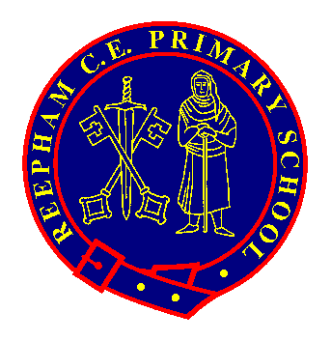
Pupils Name:

Year Group:

The ‘Reepham Rangers’ badge scheme has been created to offer opportunities to celebrate achievements outside of the National Curriculum. There are 5 badges to collect: Resilience Award, Social Action Award, Arts Award, Teamwork Award and Our World Award.

The KS2 Challenges are designed so that 2 or 3 will be able to be completed in school, but they will also require children to show commitment outside of school. This means that they will have 4 years to complete all of the challenges if they would like to achieve all the badges.

Please can you send in photos or a PPT to support the evidence for the challenges and this will allow us to check the criteria.

When your child has achieved 5 out of the 6 challenges, please return this form to their class teacher and the award will be presented in celebration worship.

BE KNOWN. BE LOVED. BELONG
Our World  Award | Examples  Please complete 5 out of the 6 challenges to achieve the award. | Evidence  (Please list the evidence below and take photos)
1) Recycle challenge. | Make something useful out of materials instead of throwing them away.  Sort your household rubbish to make sure you are recycling. Go to a bottle bank.
2) Reduce your eco footprint. | Make your pack-up waste neutral. Turn the lights off in your home. Turn taps off when you brush your teeth. Pledge to go a weekend without using a computer, tablet or games console.
3) Explore local nature. | Explore your garden or a field and log how many different plants and creatures you can find. Can you find the name of some of them?  Have an outdoor adventure and take a picture.
4) Grow something yourself. | Plant some flowers, fruit or vegetables. Look after them until they are fully grown.
5) Make a healthy meal. | Prepare a healthy meal for your family, maybe use something you have grown.  Make your own pack-up but swap in healthy choices.
6) Be a global neighbour. | Write to a pen pal in a different country.  Collect stamps or currency from a range of countries.  Research and present information on a place you have visited or want to visit. Learn the basics of another language.

School Values link: Respect, Responsibility, Friendship, Hope and Love. BE KNOWN. BE LOVED. BELONG

